**Subnetting in Networking-**

Before you go through this article, make sure that you have gone through the previous article on [**Subnetting**](https://www.gatevidyalay.com/subnetting-ip-subnetting-examples/).

We have discussed-

* Subnetting is a process of dividing a single network into multiple smaller networks.
* The number of sub networks created depends upon the requirement.

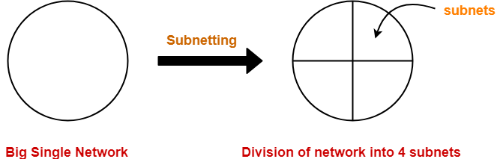

**Arrangement Of Subnets-**

* All the subnets are connected to an internal router.
* Internal router is connected to an external router.
* The link connecting the internal router with a subnet is called as an **interface**.

**Example-**

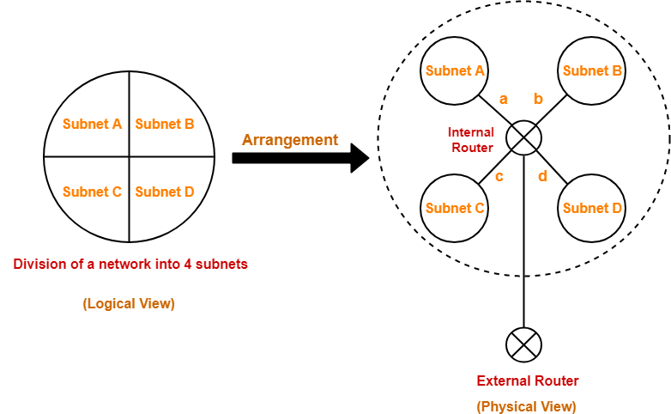

**Working-**

When a data packet arrives,

* External router forwards the data packet to the internal router.
* Internal router identifies the interface on which it should forward the incoming data packet.
* Internal router forwards the data packet on that interface.

**Routing Table-**

* A table is maintained by the internal router called as **Routing table**.
* It helps the internal router to decide on which interface the data packet should be forwarded.

Routing table consists of the following three fields-

1. IP Address of the destination subnet
2. Subnet mask of the subnet
3. Interface

**Also Read-** [**Subnet Mask**](https://www.gatevidyalay.com/subnet-mask-how-to-calculate-subnet-mask/)

**Example-**

Consider a network is subnetted into 4 subnets as shown in the above picture.

The IP Address of the 4 subnets are-

1. 200.1.2.0 (Subnet A)
2. 200.1.2.64 (Subnet B)
3. 200.1.2.128 (Subnet C)
4. 200.1.2.192 (Subnet D)

Then, Routing table maintained by the internal router looks like-

|  |  |  |
| --- | --- | --- |
| **Destination** | **Subnet Mask** | **Interface** |
| 200.1.2.0 | 255.255.255.192 | a |
| 200.1.2.64 | 255.255.255.192 | b |
| 200.1.2.128 | 255.255.255.192 | c |
| 200.1.2.192 | 255.255.255.192 | d |
| Default | 0.0.0.0 | e |

**Routing Table Example**

When a data packet arrives to the internal router, it follows the following steps-

**Step-01:**

Router performs the bitwise ANDing of-

* Destination IP Address mentioned on the data packet
* And all the subnet masks one by one.

**Step-02:**

Router compares each result with their corresponding IP Address of the destination subnet in the routing table.

Then, following three cases may occur-

**Case-01:**

If there occurs only one match,

* Router forwards the data packet on the corresponding interface.

**Case-02:**

If there occurs more than one match,

* Router forwards the data packet on the interface corresponding to the longest subnet mask.

**Case-03:**

If there occurs no match,

* Router forwards the data packet on the interface corresponding to the default entry.

**Important Notes-**

**Note-01:**

In fixed length subnetting,

* All the subnets have the same subnet mask.
* So, bitwise ANDing is performed only once.

If the result matches to any of the destination subnet IP Address,

* Router forwards the data packet on its corresponding interface.
* Otherwise, it is forwarded on the default interface.

**Note-02:**

In variable length subnetting,

* All the subnets do not have the same subnet mask.
* So, bitwise ANDing is performed once with each subnet mask.
* Then, the above three cases are followed.

**Note-03:**

* A host may also be directly connected to the router.
* In that case, there exists a host specific route from the router to the host.
* Router saves the IP Address of that host in the “Destination Network” column.
* Router saves 255.255.255.255 in the “Subnet Mask” column.
* The ANDing of its destination address and subnet mask yields the IP Address of the host.
* When a data packet arrives for that specific host, bitwise ANDing is performed.
* When the result of ANDing is the IP Address of the host, packet is forwarded to its host specific route.

**Note-04:**

* Subnet mask for default route = 0.0.0.0
* Subnet mask for host specific route = 255.255.255.255

**PRACTICE PROBLEMS BASED ON ROUTING TABLE-**

**Problem-01:**

A router uses the following routing table-

|  |  |  |
| --- | --- | --- |
| **Destination** | **Mask** | **Interface** |
| 144.16.0.0 | 255.255.0.0 | eth0 |
| 144.16.64.0 | 255.255.224.0 | eth1 |
| 144.16.68.0 | 255.255.255.0 | eth2 |
| 144.16.68.64 | 255.255.255.224 | eth3 |

A packet bearing a destination address 144.16.68.117 arrives at the router. On which interface will it be forwarded?

1. eth0
2. eth1
3. eth2
4. eth3

**Solution-**

Router performs the bitwise ANDing of-

* Destination address mentioned on the data packet
* And each subnet mask one by one.

**1st Row-**

144.16.68.117 AND 255.255.0.0

= 144.16.0.0

Since result is same as the given destination address, so a match occurs.

**2nd Row-**

144.16.68.117 AND 255.255.224.0

= 144.16.64.0

Since result is same as the given destination address, so a match occurs.

**3rd Row-**

144.16.68.117 AND 255.255.255.0

= 144.16.68.0

Since result is same as the given destination address, so a match occurs.

**4th Row-**

144.16.68.117 AND 255.255.255.224

= 144.16.68.96

Since result is not same as the given destination address, so a match does not occur.

Now,

* Clearly, there occurs more than one match.
* So, router forwards the packet on the interface corresponding to the longest subnet mask.
* Out of all, 255.255.255.0 is the longest subnet mask since it has maximum number of 1s.

So,

* Router forwards the packet on the interface corresponding to the subnet mask 255.255.255.0.
* The corresponding interface is eth2.

Thus, Option (C) is correct.

**Problem-02:**

The routing table of a router is shown below-

|  |  |  |
| --- | --- | --- |
| **Destination** | **Mask** | **Interface** |
| 128.75.43.0 | 255.255.255.0 | eth0 |
| 128.75.43.0 | 255.255.255.128 | eth1 |
| 192.12.17.5 | 255.255.255.255 | eth3 |
| default |  | eth2 |

On which interfaces will the router forward packets addressed to destination 128.75.43.16 and 192.12.17.10 respectively?

1. eth1 and eth2
2. eth0 and eth2
3. eth0 and eth3
4. eth1 and eth3

**Solution-**

Router performs the bitwise ANDing of-

* Destination address mentioned on the data packet
* And each subnet mask one by one.

**Packet With Destination Address 128.75.43.16-**

**1st Row-**

128.75.43.16 AND 255.255.255.0

= 128.75.43.0

Since result is same as the given destination address, so a match occurs.

**2nd Row-**

128.75.43.16 AND 255.255.255.128

= 128.75.43.0

Since result is same as the given destination address, so a match occurs.

**3rd Row-**

128.75.43.16 AND 255.255.255.255

= 128.75.43.16

Since result is not same as the given destination address, so a match does not occur.

Now,

* Clearly, there occurs more than one match.
* So, router forwards the packet on the interface corresponding to the longest subnet mask.
* Out of all, 255.255.255.128 is the longest subnet mask since it has maximum number of 1s.

So,

* Router forwards the packet on the interface corresponding to the subnet mask 255.255.255.128.
* The corresponding interface is **eth1**.

**Packet With Destination Address 192.12.17.10-**

**1st Row-**

192.12.17.10 AND 255.255.255.0

= 192.12.17.0

Since result is not same as the given destination address, so a match does not occur.

**2nd Row-**

192.12.17.10 AND 255.255.255.128

= 192.12.17.0

Since result is not same as the given destination address, so a match does not occur.

**3rd Row-**

192.12.17.10 AND 255.255.255.255

= 192.12.17.10

Since result is not same as the given destination address, so a match does not occur.

Now,

* Clearly, there occurs no match.
* So, router forwards the packet on the interface corresponding to the default entry.
* The corresponding interface is **eth2**.

Thus, Option (A) is correct.

**Problem-03:**

Host specific route has a subnet mask of _____ in the routing table.

1. 255.255.255.255
2. 0.0.0.0
3. 255.0.0.0
4. 0.0.0.255

**Solution-**

Option (A) is correct.

**Problem-04:**

Default route has a subnet mask of _____ in the routing table.

1. 255.255.255.255
2. 0.0.0.0
3. 255.0.0.0
4. 0.0.0.255

**Solution-**

Option (B) is correct.

**Problem-05:**

Default route can be described as-

1. Destination values of 0.0.0.0 in the routing table
2. It can be used if network has only one next hop router
3. It is useful in keeping routing table small
4. All of the above

**Solution-**

Option (D) is correct.

To gain better understanding about Routing Table,